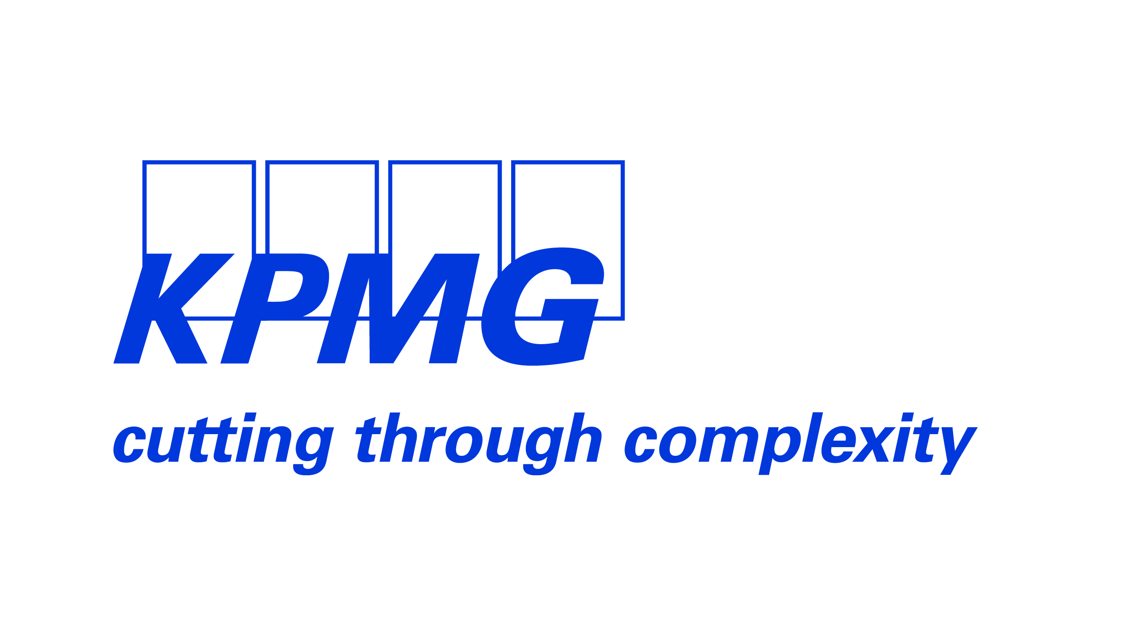
Press Release KPMG – 10 February 2014

Always one step ahead, says KPMG

KPMG’s Executive Committee explains how KPMG Luxembourg has undergone a transformation in 2013, by taking a long-term, sustainable approach to business.

Georges Bock, Managing Partner
“Anticipating the next lasting trend is as crucial as excelling in operations today. Companies with one eye on the future consistently outclass their competitors – we want to help our clients to be this kind of forward-thinking company. To do this, we have identified major global megatrends that will also have a significant transversal impact on Luxembourg and across many different sectors. KPMG Luxembourg has identified Economic Interconnectedness, Enabling Technology and Economic Power Shift as the main driving forces which will significantly impact Luxembourg and its financial sector in the coming years. The agility with which clients respond to these developments now will shape their future in years to come.

KPMG sees an opportunity for Luxembourg to position itself ahead of the curve in terms of these trends. This conviction - which is based on analysis - has led to innovation in service delivery, as we reinvent the way we provide quality service to our clients. We have put in place new models to better serve both today’s and tomorrow’s expectations and needs.”

Megatrend 1: Economic Interconnectedness

Alain Picquet, Head of Advisory
“With one of the most globalized economies on the planet, Luxembourg is at the vanguard of the move towards interconnection. Increased interdependence brings significant potential for growth and collaboration and we have long worked alongside our clients to capitalize on this. Yet the flipside to this trend is the risk of contagion that new complex trade and investment relationships bring. The continuous avalanche of regulation is only set to continue as governments legislate to try to mitigate these risks. KPMG is helping its clients to cope with this megatrend by providing integrated services to take the burden off them and onto us. Our KPMG Racer, for example, is a suite of services that allows companies to wholly outsource tax, risk management, valuation and reporting – our best-seller being AIFMD reporting. Our Regulatory Scout service offers clients a dedicated team to keep a watch and help plan for regulation, allowing them to focus on their core business and secure peace of mind.”

Megatrend 2: Enabling Technology

Georges Bock, Managing Partner
“Information and communication technology (ICT) is connecting people both in and outside Luxembourg and disrupting existing business models. The pace of change is continually increasing and technology itself is driving an acceleration in the speed of life. Mobile payments, data protection, crowdfunding and the rise of digital content are just a few examples of technological sub-trends and potential business disruptors. Helping clients understand the impact that enabling technology will have on their business is a first step towards unleashing “leapfrog” opportunities and finally harnessing the power of digital transformation, Social Media, Big Data and related business analytics. Always one step ahead.”

Megatrend 3: Economic Power Shift

Emmanuel Dollé, Head of Audit
“Emerging market economies are becoming increasingly important players in international finance. Power is shifting from the developed world to these new hubs of influence and each new economy that blooms brings with it potential consumers, opportunities and challenges. If Luxembourg is to stay at the center of these shifting financial powers, it needs to reinvent itself, show greater understanding of multicultural opportunities and risks and establish a strong reputation for itself beyond traditional western circles. At KPMG, we are working on a daily basis with our global network to understand and face these new challenges together. To be even closer to where our clients are doing business, we have developed international expertise locally, with Chinese, Japanese and Russian desks here in Luxembourg.”

Thomas Feld, COO
“What we have achieved for our own firm this year is exactly what we are helping our clients to achieve: transformation. Creating future-ready services has required investment in people, expertise and infrastructure – as shown in our key figures - but there is still some work to be done. With our move to 39, Avenue Kennedy this year, we advance towards our vision of creating a state-of-the-art environment for our clients and people, combining three key elements: community, efficiency and lifestyle. Spacious open work areas, quirky meeting spaces, a bistro, food court and coffee bar: places to come together to exchange ideas and create new ones.”

Sebastien Labbé, Head of Tax and People
“Behind KPMG’s success is its people and the quality and value they ingrain in their work. Our staff have brought the same commitment to our transformation as they consistently bring to their everyday responsibilities. This commitment explains the trust our clients place in us and the strength of the relationships they have with our employees.”

THE TOPLINE
KEY FACTS
REVENUES | AUDIT CONTRIBUTION | ADVISORY SERVICES
€138m | €70m | €68m
(€132m: 2012) | (€68m: 2012) | (€64m: 2012)
LUXEMBOURG EMPLOYEES | NEWCOMERS | PROMOTIONS
1 199 | 293 | 291
in December 2013 | in September/October 2013 | in October 2013
DONATIONS
€230K
to charity

Follow KPMG Luxembourg on:

Press contact
Geneviève Feyt
Tel: 22 51 51 2903
Mob: 621 87 2903
E-mail: genevieve.feyt@kpmg.lu

